727721EUIT147

CC1

1

package com.zest.CA1;

import org.openqa.selenium.By;

import org.openqa.selenium.WebDriver;

import org.openqa.selenium.WebElement;

import org.openqa.selenium.chrome.ChromeDriver;

import org.openqa.selenium.chrome.ChromeOptions;

import io.github.bonigarcia.wdm.WebDriverManager;

public class CC1_1 {

public static void main(String[] args) throws InterruptedException{

WebDriverManager.*chromedriver*().setup();

ChromeOptions co=new ChromeOptions();

co.addArguments("--remote-allow-origins=*");

WebDriver driver=new ChromeDriver(co);

driver.get("https://www.saucedemo.com/");

driver.manage().window().maximize();

WebElement r=driver.findElement(By.*xpath*("//*[@id=\"user-name\"]"));

r.sendKeys("standard_user");

Thread.*sleep*(2000);

WebElement d=driver.findElement(By.*xpath*("//*[@id=\"password\"]"));

d.sendKeys("secret_sauce");

Thread.*sleep*(2000);

WebElement login=driver.findElement(By.*xpath*("//*[@id=\"login-button\"]"));

login.click();

Thread.*sleep*(2000);

driver.findElement(By.*xpath*("//*[@id=\"add-to-cart-sauce-labs-backpack\"]")).click();

Thread.*sleep*(2000);

String actual=driver.getCurrentUrl();

String expected="https://www.saucedemo.com/inventory.html";

if(actual.equals(expected)) {

System.***out***.println("Product is added to cart");

}

else {

System.***out***.print("Product is not added to cart");

}

driver.findElement(By.*xpath*("//*[@id=\"shopping_cart_container\"]/a")).click();

Thread.*sleep*(2000);

String actual2=driver.getCurrentUrl();

String expected2="https://www.saucedemo.com/cart.html";

if(actual2.equals(expected2)) {

System.***out***.println("Cart is displayed");

}

else {

System.***out***.print("Cart is not displayed");

}

driver.findElement(By.*xpath*("//*[@id=\"checkout\"]")).click();

Thread.*sleep*(2000);

String actual1=driver.getCurrentUrl();

String expected1="https://www.saucedemo.com/checkout-step-one.html";

if(actual1.equals(expected1)) {

System.***out***.println("Checkout form is dispalyed");

}

else {

System.***out***.println("Checkout form is not dispalyed");

}

driver.findElement(By.*xpath*("//*[@id=\"first-name\"]")).sendKeys("SHREEJA");

Thread.*sleep*(2000);

driver.findElement(By.*xpath*("//*[@id=\"last-name\"]")).sendKeys("ELANGOVAN");

Thread.*sleep*(2000);

driver.findElement(By.*xpath*("//*[@id=\"postal-code\"]")).sendKeys("627007");

Thread.*sleep*(2000);

driver.findElement(By.*xpath*("//*[@id=\"continue\"]")).click();

Thread.*sleep*(2000);

String actualurl=driver.getCurrentUrl();

String expurl="https://www.saucedemo.com/checkout-step-two.html";

if(actualurl.equals(expurl)) {

System.***out***.println("Overview page is displayed");

}

else {

System.***out***.print("Overview page is not displayed");

}

String s=driver.findElement(By.*xpath*("//*[@id=\"item_4_title_link\"]/div")).getText();

System.***out***.println("Product name:"+s);

String b=driver.findElement(By.*xpath*("//*[@id=\"checkout_summary_container\"]/div/div[1]/div[3]/div[2]/div[2]/div")).getText();

System.***out***.println("Product price:"+b);

driver.findElement(By.*xpath*("//*[@id=\"finish\"]")).click();

Thread.*sleep*(2000);

String actual4=driver.getTitle();

String exp4="Swag Labs";

if(actual4.equals(exp4)) {

System.***out***.println("Title Validated");

}

else {

System.***out***.print("Title Not Validated");

}

}

}

OUTPUT:

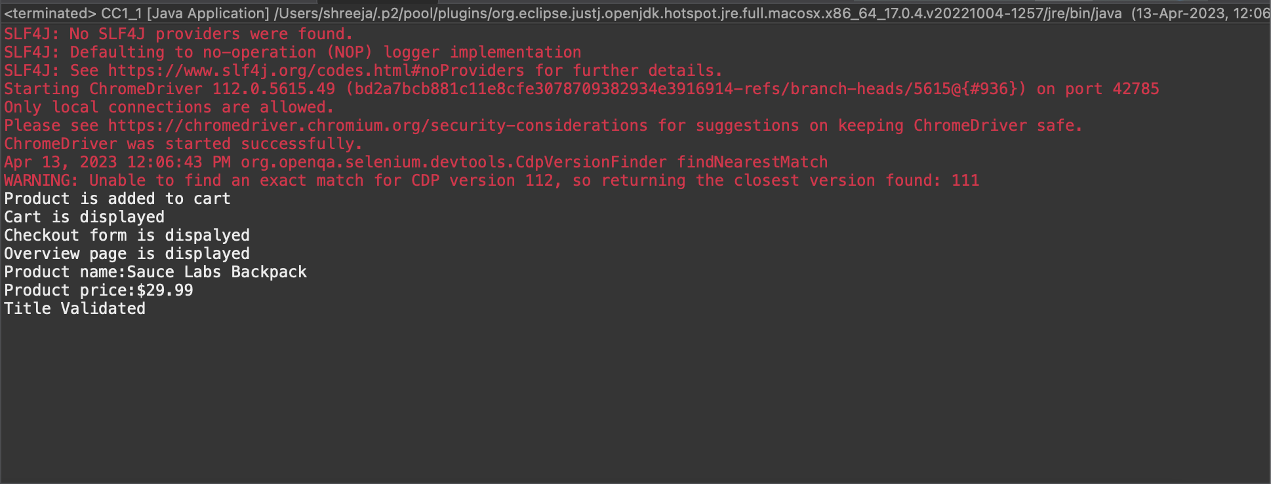2

package com.zest.CA1;

import org.openqa.selenium.By;

import org.openqa.selenium.WebDriver;

import org.openqa.selenium.WebElement;

import org.openqa.selenium.chrome.ChromeDriver;

import org.openqa.selenium.chrome.ChromeOptions;

import io.github.bonigarcia.wdm.WebDriverManager;

public class CC1_2 {

public static void main(String[] args) throws InterruptedException{

WebDriverManager.*chromedriver*().setup();

ChromeOptions co=new ChromeOptions();

co.addArguments("--remote-allow-origins=*");

WebDriver driver=new ChromeDriver(co);

driver.get("https://www.saucedemo.com/");

driver.manage().window().maximize();

WebElement r=driver.findElement(By.*xpath*("//*[@id=\"user-name\"]"));

r.sendKeys("standard_user");

Thread.*sleep*(2000);

WebElement d=driver.findElement(By.*xpath*("//*[@id=\"password\"]"));

d.sendKeys("secret_sauce");

Thread.*sleep*(2000);

WebElement login=driver.findElement(By.*xpath*("//*[@id=\"login-button\"]"));

login.click();

Thread.*sleep*(2000);

driver.findElement(By.*xpath*("//*[@id=\"header_container\"]/div[2]/div/span/select")).click();

String s=driver.findElement(By.*xpath*("//*[@id=\"item_4_title_link\"]/div")).getText();

System.***out***.println("Name A-Z Product:"+s);

String a=driver.findElement(By.*xpath*("//*[@id=\"item_3_title_link\"]/div")).getText();

System.***out***.println("Name Z-A Product:"+a);

String b=driver.findElement(By.*xpath*("//*[@id=\"item_2_title_link\"]/div")).getText();

System.***out***.println("Price low to high:"+b);

String c=driver.findElement(By.*xpath*("//*[@id=\"item_5_title_link\"]/div")).getText();

System.***out***.println("Price hight to low:"+c);

}

}

OUTPUT:

